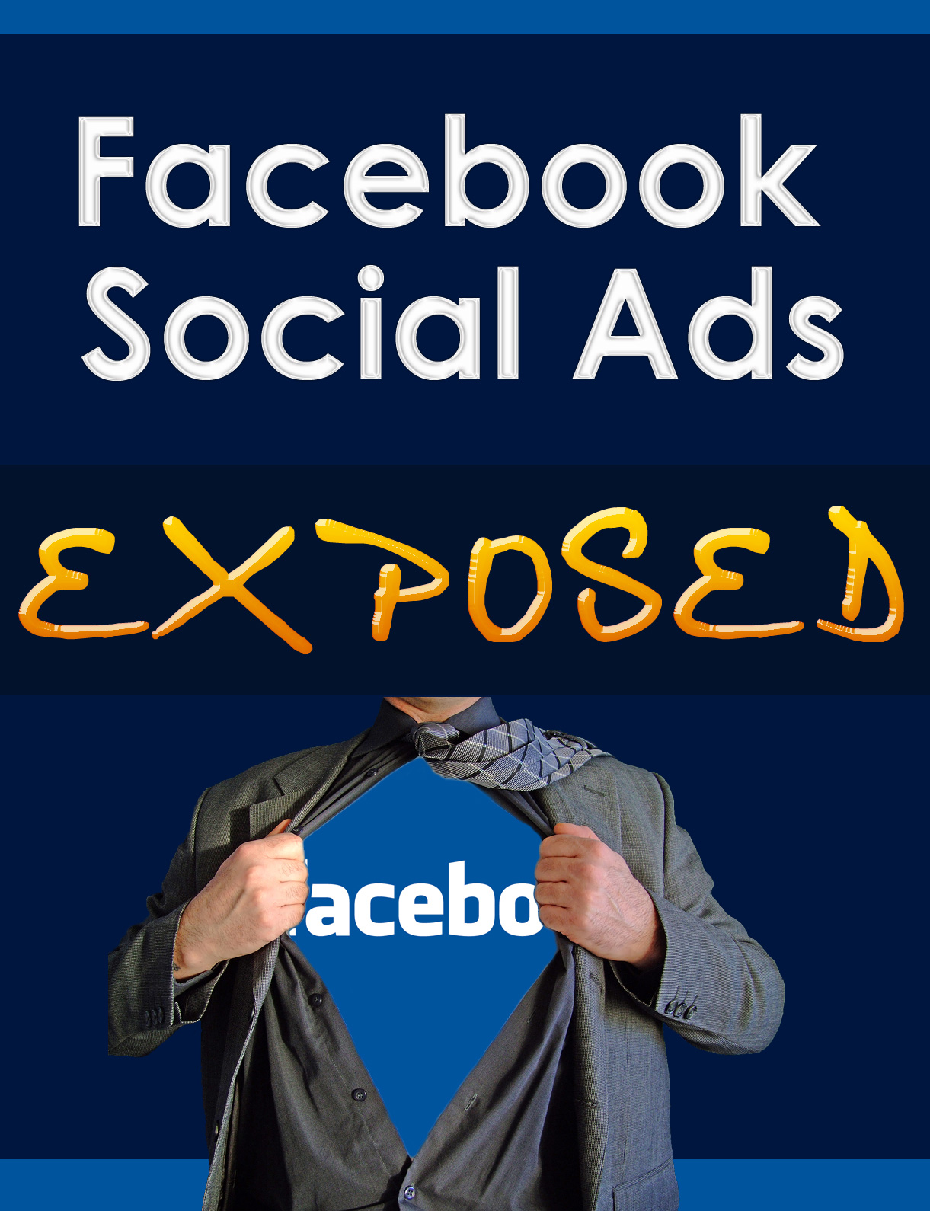

Facebook Social Ads Exposed

Brought To You By:

-8-YourName-8-
-8-YourWebsiteURL-8-

Table Of Contents

Table Of Contents 3

Section I: Facebook Social Ads Exposed 5

How Facebook Social Ads Work 5
A Case Study: Zynga’s “Farmville” 7
The Importance of Planning… and Facebook Users 10

Section II: Getting Down to Business 12

The Facebook Platform 12
Facebook Ad Creation – The Process 14
What’s the Deal with Facebook Beacon? 19
Facebook Fans 20
Do Keywords Still Matter? 20
What Type of Events or Items Can I Advertise? 22
Should Facebook Ads Replace Google AdWords? 24

Section III: Maximizing your Facebook Exposure 25

Sweepstakes and Contests 25
Facebook Social Ad Branding 26
Facebook Marketing Solutions 27
Facebook Fan Pages 28
7 Tips for Making the Most of your Facebook Fan Page: 29
Facebook Groups 31

Section IV: The Down Side of Facebook Ads 33

9 Facebook Ad Mistakes 35
The Privacy Issue 37

Section I: Facebook Social Ads Exposed

Facebook Social Ads work virally, but rather than being spread in a random fashion, they are placed on Facebook members’ pages, based on their profile data – which can make them a powerful sales aid for marketers – especially in this current decade, where mobile devices are now replacing personal computers at the rate of 4 – 1.

However, like any data system spread via the net, there are rules, restrictions and random factors that can greatly inhibit or enhance their success. In this Special Report, we will explore the ins – and outs – of Facebook Social Ads.

What this Report is Not…

It is not a complete guide to Facebook Ad Creation. Instead, it focuses more on the nuances you will not pick up from Facebook’s easy “Advertising Creation” walk-through… and drawbacks to watch out for.

How Facebook Social Ads Work

Marion loves horseback riding, and publicly says so in her Facebook profile.

A successful Equestrian Center wants to promote its children’s summer camp, so it purchases a Facebook Ad.

Facebook uses Insight, a powerful demographics tool, to place the Ad via a feed on Marion’s profile, after extracting the information that she has 3 children, is passionate about all things equestrian and lives within a close geographical radius of the Equestrian Center, so is a likely candidate to view the ad.

Since it’s her passion, Marion always pays attention whenever there’s a picture of a horse in an ad – and she also notices the Equestrian Center provides riding for those with Special Needs (a cause dear to her heart) so she clicks the “Like This” button and views the Ad.

Facebook then finds more ads using this specialized search data – voluntarily provided by Marion – to place other equestrian offerings in her Ad feed. (It also adds special needs-related ads, since this was one of the keywords the ad used.)

But there’s more: Marion has 97 friends on Facebook. 23 of these friends are also connected to her via equestrian activities. They read that Marion “likes” our mythical Equestrian Center and has become its Facebook Fan. Trusting her judgment and recommendation, they click on the link…

You can see instantly by this example that the combination of becoming a fan and having ads served by profile-targeted feed considerably increases your chances, as an Advertiser, of having your ads read by the right people.

Furthermore, assuming that a percentage of Marion’s 23 equestrian friends do read the geo-targeted Ad, 8 of them not only send their children to the summer camp but 18 (each of whom has anywhere from 9-30 equestrian friends) also select “become a fan”. Even with this hypothetical example, you can instantly see the potential for our mythical but well-marketed equestrian center to spread virally… all within a highly focused group more likely to buy.

Before you know it, our mythical equestrian center has a real following.

A Case Study: Zynga’s “Farmville”

Now the previous example dealt with a highly specialized niche. It might have been a broad one, but the mention in the ad of riding for special needs people and equestrian summer camp in a specific geographic area narrowed it down to reach its ideal target market – Marion and her friends.

But if you have a site that has the potential to go viral on a more global basis – such as Zynga network’s “Farmville” game – your success might be capable of reaping in millions of dollars, in a comparatively short time.

Let’s look at how Zynga did it…

- Created a simple but addictive game
- Included an application for retrieving game components (animals, flowers, vehicles, buildings, etc.)
- Included both free and paid options (a “market” in which you purchase items either with game-supplied free coins or literally purchasing special “Farmville Dollars” via credit card or PayPal. This allowed players to buy limited-time specialty virtual items; or send them to friends)
- Allowed an option for others to “Add Neighbors” – and “invite” them to Farmville
- Made sure neighbor interactivity was an almost-essential component of the game

But note what they didn’t do…

When Farmville initially placed their Ads via Facebook Ads, they said nothing about purchasing actual Farmville Dollars via credit card or PayPal: They just invited people whose profiles indicated they liked online games (or farming, or graphics puzzles) to play the game. The initial core group who tried it loved it so much, they had no hesitation splurging on actual Farmville dollars to purchase the virtual highly-prized items obtainable only through real-world payment.

In addition, players were able to eagerly invite Farmville “neighbors” from their own select group of friends – neighbors these players themselves automatically pre-screened for Zynga – and these neighbors all enjoyed sending each other “gifts”; some “free”, some purchased with Farmville dollars.

One reason Farmville has caught on so firmly? Its interactivity, a huge component in creating loyalty and a sense of community on Facebook pages. Today, as of this writing, Farmville has 23,029,163 fans.

23 million… That’s a lot of “fans”!

Zynga didn’t stop there in their game development, however: They made sure that those who did not have a lot of friends, or who had ethical objections to spreading items virally, would be unable to expand without either (a) inviting friends to be their “Farmville neighbor” or (b) literally purchasing “Farmville Dollars”. Either way, Zynga wins!

(Paying hard cash for virtual items has caught on like wildfire, all across the net. PayPal processed “about $500 million in virtual goods payments last year”, according to Citi analyst Mark Mahaney’s estimate. And, according to: Inside Facebook, Zynga was “PayPal’s second largest merchant in 2009”!)

Note that, as part of their Facebook game page, Zynga provides links to:

- A Farmville blog
- A weekly Podcast
- A steady stream of limited time “special items”
- A forum
- A press release campaign
- Interviews granted to magazines and websites
- Entries in contests such as Escapist Magazine’s yearly game development competition
- Special, additional “Farmville Fan” feed, so that the games players will be aware of its promotions, and take actions such as voting for them in website competitions
- Tips
- Alternate web access information, in case Facebook is down… and to convert hard-core players over to their own dedicated website, which provides even more neighbor feed
- Promotional information to create a buzz about “new” animals and features about to be introduced
- Multiple areas you can click to access all of the above

But make no mistake – Zynga’s multi-million-dollar success all started with one simple little game… initially helped to spread by a well-written, inexpensive Facebook Social Ad!

The Importance of Planning… and Facebook Users

Zynga’s Farmville (and its wildly-popular subsequent offerings) could serve as the ultimate model for using Facebook Social Ads to the max. It’s not enough just to create and pay for the actual Ad, of course – you have to thoroughly research your competition and your market, plan for expansion and publicity, and maximize every advantage sitting waiting for you on Facebook’s powerful social-oriented platform.

You also have to realize that people are finding these type of products not by typing a long-tailed key phrase into Google’s search engine… but by going onto Facebook and waiting to see what Facebook serves up specially suited to their preferences.

Facebook users could go to the application directory, but when it comes to something like a game, 18 Farmville players admitted during a “spot” survey conducted prior to this report being written that they started playing Farmville only one of two ways:

- They were “invited” by friends to become Farmville neighbors
- They “finally” succumbed to repeated Facebook Ads
Not one of them said they went out and deliberately looked for a farming game to play.

(That’s the difference between your Facebook users and Google searchers.)

Okay: We’ve finished with our case study… let’s have a look at Facebook Ads – the good, the bad, and the downright ugly…

Section II: Getting Down to Business

The Facebook Platform

Facebook’s platform allows almost anyone to develop widgets and applications, which are placed in the Applications directory, where anyone can grab an App and “place” it on their Profile page. It also gives “click and point” ability for people to include or exclude things on their profile (including Ads they like – or don’t like!)

Facebook users report liking the feel of control they have over Ads that appear in their right-hand sidebar. If a particular subject or Ad annoys them, they can choose not receive similar ones.

They can “Like” your Ad (leading to more – and to its repetition)… or “Report” it, if they deem it misleading or inappropriate (or even if they’re just in a cranky mood that day!)

Remembering this should help you target your audience even more carefully.

Keep 3 things always in mind, however, when you prepare to create your Ads…

Social relevance

Social enjoyment

Social interest

Facebook also allows you to announce and promote events, create a Group Page or create a company, business or personal Fan Page.

You can link your Facebook Ads very easily to any of the above – and therein lies one of Facebook Ads’ biggest advantages!

And now let’s have a quick look at the process…

Facebook Ad Creation – The Process

The actual ad creation itself is an incredibly simple, 3-step process. Facebook virtually walks you through it every step of the way, and even a beginner can quickly get the hang of it: However, it always pays to know how Facebook ads work in the real world, as well as familiarizing yourself with all the factors that affect Facebook Advertising success or failure, so you can plan your Advertising campaign wisely, well in advance.

The basic process runs like this: You either visit Facebook Advertising directly – or click on the “Create an Ad” link that will appear regularly in your Facebook page right-hand sidebar (along with all the other Ads targeted to your preference that you usually see). Once you click on the link, you are taken to this page:
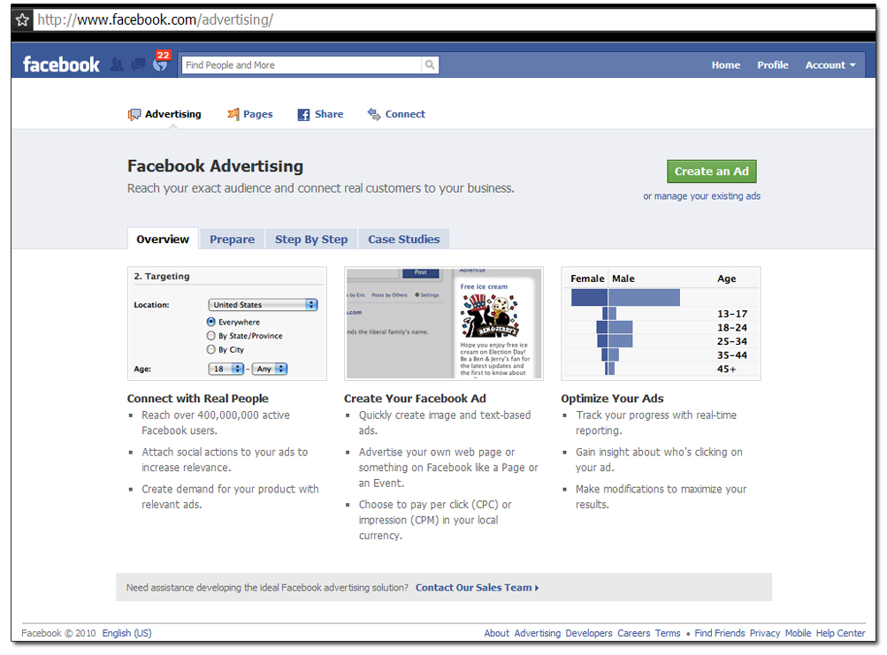
You click on each of the 4 tabs in turn (and there are additional links, if you need more in-depth information; as well as – you’ll notice – a “Contact Our Sales Team” link in the bottom bar).

It’s so simple that it would be redundant to repeat the whole process here, but it helps to know some additional factors affecting the Ads, as well as tips for producing the best-converting ones.

Let’s answer some common (and not-so-common) questions…
Are They Free?

No. But Facebook Social Ads are a less expensive option than Google AdWords – and if you want to reach that segment of your potential niche market who operate solely on mobiles, or who spend all their days on Facebook, they are essential. (Don’t forget that Facebook Mobile is going to play a huge part in displaying your ads!) You can choose either pay-per-click (PPC) or pay-per-impression (PPM).

You are charged a pre-arranged amount for your PPC ad every time someone clicks on it.

With PPM, you are charged per impression (an `impression’ being the number of times your ad appears).

You pay lump sums in advance by purchasing “credits”. Your clicks or impressions are then deducted from these credits. (You can purchase credits in as small an increment as $20.) Your ad will run as long as you still have credits remaining. You can top up your credits to keep it running, or let it run out and edit/tweak your Ad further.

There are no fixed costs for Ads, but Facebook actually helps you determine what a good rate to set would be, based on criteria you enter in their targeting formula. (You can also set your Ad to end at a specific point… or run continuously.)

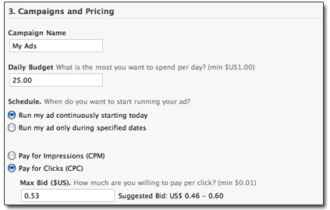

When calculating your ROI (return on investment) on your Facebook Ads, you would do it the same way as for any other advertising venue.

How Do You Track Your Facebook Social Ads?

Without the ability to track an Ad, its effectiveness drops dramatically.

Fortunately, Facebook has a platform named Facebook Insights, which allows you to view the number of clicks and impressions your Ad receives in real time.

How Should I Target my Facebook Ads?

There’s no cut-and-dried answer to this, except to make sure your keywords are actually suited for the way Facebook operates… and the way it dispenses ads (based on keywords in user profiles).

Here are some solid elements to start with, directly from Facebook’s Ad creation site…

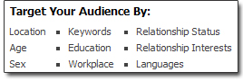

Start with targeting by country – other options will be presented to you, based on the country you select (and you can actually select up to 25, though this will preclude you from being specific as to city).

You always have to keep in mind that this is a social network: Find Groups or Fan Pages similar to your own interests, and see what keywords they seem to be using… But remember, above all, Facebook for its users is all about easy entertainment – not concentrated searches.

Are Facebook Ads Automatically Approved?

No. All Ads have to be submitted for approval. Facebook states: “We do reserve the right to choose what advertising we accept, and may prohibit additional content from being advertised on the site based on user feedback or other information.”

If your Ad is not approved, not only will you receive an official “Disapproval Email”, but you’ll also be able to see this information in your Ads Manager, beside a copy of the disapproved Ad.

What’s the Deal with Facebook Beacon?

In 2007, Facebook launched “Beacon”, a program that tracked Facebook users (even when they weren’t logged in) and published user activity, without permission, as part of deals with Advertisers.

What it meant, in real world terms, was that you could find your online purchases and activities publicized on Facebook for all to see – and you had no say in the matter.

A class action lawsuit was launched against Facebook and other major companies participating in this type of activity, and in 2009 Facebook yielded to pressure and shut Beacon down, allocating $9.5 million dollars to settlement fees. Prior to that, however, Beacon partners such as The New York Times and Coca-Cola had already voluntarily dropped Beacon, because their own users’ information was appearing on the pages of “controversial individuals and groups”, according to Wikipedia.

Beacon was a complete fiasco – for Facebook and Advertisers alike. Perhaps it’s a stretch to say it’s been “replaced” by Facebook Fans, but that too places user photos and information on Facebook, without specifically asking permission. Facebook has learned from Beacon, however, and now as a user, you have to specifically opt-in before any data is used.

This brings us to…

Facebook Fans

Involuntary user endorsement is now strictly an opt-in procedure, via Facebook Fans. For example, Farmville users who click “become a fan” can expect to occasionally see their name and photograph published in Farmville’s feed (along with a random daily sampling of other fans)… unless they specifically veto this in their Settings.

Usually, people aren’t bothered by seeing their photos appear within select groups because:

- That user chose to “become a fan”
- The information typically appears within the Farmville “group” only
Where it gets really sticky: When your users’ photos appear on “outside” sites – though a major portion of this problem has been corrected. (More on privacy, later.)

Do Keywords Still Matter?

Yes. Not in the traditional SEO sense, but for targeting Facebook user profiles. A good way to get a feel for this is to survey the Facebook profiles of people who like similar sites, products or pages to yours.

If your business is a physical location you want people in your area to visit, you will particularly want to make sure you include your city and state/province in your Ad text.

You can also find and research more targeted keywords by studying those Facebook profiles and seeing which keywords they have in common that relate to your potential Ad.

What Type of Events or Items Can I Advertise?

You can Advertise:

- Web pages
- Facebook pages created by you
- Facebook groups which you administrate
- Applications
- Events publicized on Facebook

Facebook Ads probably should not be your first choice for straight business advertising or direct product promotion – Google SEO is better for that purpose – but yes, you can use Facebook Ads to help promote your business indirectly and definitely for creating a buzz about it (for example, promoting a Facebook Page that popularizes some aspect of your business, to help you firmly establish a branded presence).

(An ideal combination for many businesses would be a “double whammy” sandwich of both Facebook Social Ads and traditional Google SEO-based ones.)

When deciding how to use Facebook Ads for your business, just think “social” and “random entertainment”, and if you can see a way to make your business fit, you’re on the right track.

Can I Advertise an Affiliate Product with Facebook?

If you are creative and read the guidelines thoroughly – yes, you can promote an affiliate product. Just keep in mind that any link you provide has to go directly to the destination URL.

Your Ad should not be a direct sales pitch for that product (remember, “social”) but should provide incentive for the user to visit the site.

Should Facebook Ads Replace Google AdWords?

We’ve already dealt with the whole business-versus-social issue between Google SEO and Facebook: The same principles apply for Google AdWords.

If you want to aggressively promote a product or business directly, use AdWords. If you want to expand it’s popularity, create a buzz or you feel it’s particularly suited to Facebook’s resources, use Facebook Ads.

One thing you can do with Facebook Ads that makes it a good choice for beginners wary of losing major money on AdWords: You can easily set the Ad to terminate after the amount of credits you purchase is depleted. This makes it a safer bet than finding yourself with a massive credit card bill at the end of the month (something beginners often get caught by with AdWords).

The bottom line, however, should be related to the best use of your Ad dollars. If Facebook Ads is your choice solely because you are seriously strapped for cash, don’t expect over-the-moon results, since you’re operating with only a small part of the whole picture.
Section III: Maximizing your Facebook Exposure

It’s not enough just to create Ads for a webpage. You want to make sure you get the most out of your Advertising dollars by maximizing Facebook’s platform in as many diverse areas as possible (just as we’ve seen Zynga do, in our case study).

Here are some ideas, and some extra Facebook-related resources to consider…

Sweepstakes and Contests

Ads for contests and sweepstakes are generally not allowed… unless you first obtain permission from Facebook.

There are a number of other restrictions that are ironclad and will never garner that coveted permission if you ignore them; and you need to be aware of these.

For example, you may not create promotions marketed for:

- People who are under 18 years of age
- Countries currently under U.S. embargo
- The promotion of prescription drugs, gambling, firearms, tobacco or gasoline
- The obtaining of a prize which includes or consists of prescription drugs, firearms, or tobacco

Sweepstakes too have highly specific rules applied. You are forbidden to run them via Facebook Social Ads if:

- Entry is dependent upon the purchase of a product or completion of a complex task

And you can specifically only promote one if:

- Your sweepstakes is open to “individuals residing in Belgium, Norway, Sweden, or India”

The long list of prohibitions at first looks daunting: However, one quickly realizes that Facebook is now attempting to weed out promotions that are shady, illegal or fraudulent. If yours is none of these things, and you adhere to delivery methods and ensure you are not inadvertently violating rules, Facebook will most likely be only too happy to grant you permission. So be sure to check out the Facebook Promotions Guidelines in advance for yourself, if you are hoping to hold a contest or sweepstakes – for any purpose (even charitable).

In the long run, these rules and prohibitions are just good business sense – for all!

Facebook Social Ad Branding

Facebook Social Ads are a quick way to help you brand your product or website. But exactly how do you do that?

Here are some tips:

  - Be authentic
  - Be transparent (speak as openly to customers as you would to close friends)
  - Build trust
  - Remember it’s all about the feeling of connection and community

Facebook Marketing Solutions

One site you should bookmark and check daily, if you are considering advertising with Facebook, is Facebook Marketing Solutions.

That’s where you’ll instantly see:

- What the “big guns” (with the big budgets) are doing
- What your competitors are doing
- The latest trends
- The latest Advertising news
- The latest “movements” (akin to promotions, but more socially-driven)
- Up-to-the-minute insider tips
- Marketing ideas

Facebook Solutions is actually run by Facebook employees. You can create movements yourself, and share information through Facebook. (Any content you submit should relate directly to marketing.)

You can submit:

- Links
- Photos
- Videos
- Posts

These should be geo-targeted, as well as geared to your fans.

Facebook Fan Pages

When your reader clicks that “become a fan” button, that shouldn’t be the end of it! You need to provide her with a place to go, to reward her for taking that action.

Your Facebook Fan page is your public page for your business entity identity – the one you’re promoting in your Ads. Fan pages not only help you “brand” your business entity, but give you a reliable way to build your presence on Facebook.

The main 2 points to remember: Keep it personal and keep it connected with your fans.

Your fan page should be the place to go where your customers can go to read privileged information they won’t be able to find elsewhere – the latest news tidbits, the latest releases, pre-release information, tips, contests, fixes and bonuses.

It should be a place each fan is eager to visit.

Most of all, it should be a page where you actively engage your fans.

And you should have one because that’s where your Ad will link back to!

7 Tips for Making the Most of your Facebook Fan Page:

- Decide on a tone for your page. Is it going to be chatty? Young? Old? Humorous? “Up”? Reflective? Healing? Only you can answer that question… but your tone should be consistent with the “persona” you want your company (or you) to display

- Use interactive media (reviews inviting reader opinion, videos inviting commentary, discussions, charming little graphic games, quizzes or puzzles).

(They tell you never to use humor in business… but Fan Pages are ideally suited to humor, as long as your business entity is also suited to it. You can use humorous games and videos to engage and entertain your viewer – and Facebook is all about the entertainment!)

- Add a Facebook “Like” link so that people can judge your videos and puzzles. You might think that’s risky… but notice there is no “DISlike” link provided!

- Provide rewards for fans – especially if they help spread the word. This is not the same as providing an affiliate link: The “rewards” could be as small as free virtual gifts they can access.

- If appropriate, provide real-time status updates – give people a reason to constantly refer to your fan page.

- Consider displayer user-created content on your page. This can be risky, but monitoring it so you can quickly remove truly inappropriate content will not only help keep things positive, but ensure your other fans don’t get put off by unpleasant content.

- Make sure you place your Fan Page under the best category – one with what Facebook likes to call “social relevance”.

The category in which potential fans are likely to visualize a business like yours (it may not be the most obvious!)

You might be asking yourself “what do Fan Pages have to do with Advertising?” The short answer is: “Everything!”

It all goes towards making sure people read your Ads and are reminded your business entity is wonderful, every time they see one. It ensures they’ll press the “Like” button, increasing the likelihood of sending their friends to click on your ads and “become a fan” – and stay engaged with you and your products – too.

You can also do things such as tying advertising campaigns to special events – either “broad” ones such as the winter Olympics or the Super Bowl… or “local” ones such as your local Trillium-circuit horse show. (You can also ad to your company’s positive image by tying advertising campaigns to causes: "for every virtual shamrock you send, $1.00 will be donated to...”) But don’t just stop there – reinforce your Ad campaigns by also publicize these special events and your offer on your Fan Page.
But the one thing never to lose sight of…

Your Facebook Fan Page should be fun, or at the very least, rewarding to visit.

Make them want to come back as eagerly as Farmville fans visit Farmville!

Facebook Groups

If you don’t link your Ad back to a Facebook page, your other option is to link it back to a group.
A Facebook group is basically one profile shared among multiple members.

It’s divided into two vertical columns. The left column contains information about the members, a discussion board, a Facebook group Wall, updates on group news and videos. The right column contains the “extras” – pictures, related groups, links (including the option to join or leave the group), trivia sharing, and privacy information.

You can send messages directly to group members’ inboxes, but you can’t see your traffic stats, the way you can with Facebook Pages. You also cannot create new applications for your group (you can with a Facebook Page).

Section IV: The Down Side of Facebook Ads

Like any system, Facebook Ads has its own drawbacks: Some of them the same drawbacks you’ll find in any online advertising system, and some unique to Facebook. Let’s take a detour and make sure our eyes are opened wide to the dangers.

While it’s true that as a form of pay-per-click (PPC), a Facebook Ad can reach a more tightly-focused demographic and cost considerably less – partly because mainstream marketers haven’t yet discovered the potential waiting to be mined – it is nevertheless possible to rack up costs pretty quickly! One way to combat this: Have a daily budget, and set limits.

There are also rules and restrictions you need to keep in mind, so before deciding to create your Facebook Ad, make sure you thoroughly read the guidelines.

These guidelines are broken down into sections:

- Accounts
- Landing pages/Destination URLs
- Facebook References
- Ad copy and Image Content
- Prohibited content (a large section!)
- Data and Privacy
- Targeting
- Prices, Discounts and Free Offers
- Subscription Services
- Ads for Alcoholic Beverages
- Copyrights and Trademarks
- Spam
- Incentives
- Downloads

This page also contains a list of exclusions and formatting rules you need to observe, if you’re using the Facebook Platform.

There are ways to legally and ethically work your way around some of the restrictions; others are absolute.

For example, one of the general restrictions is: “No contests or sweepstakes”, but Zynga got around this by simply asking Facebook’s permission, and following the Promotion Guidelines for permitted contests.

There are other rules in which you simply have to present your case to Facebook:

- No multiple Facebook accounts for advertising purposes unless given permission by Facebook
- Advertisers can’t automate account or ad creation unless given permission by Facebook
And some that are absolute: For example…
- Ads that contain a URL or domain in the body must link to that same URL or domain.
- Ads must send users to the same landing page when the ad is clicked.
Do remember that if something is not self-evident, or your particular set of requirements goes outside the norm, you can always talk to the sales team in person, to see if there’s a way you can both make what you want to do work. (After all – they want your money!)

9 Facebook Ad Mistakes

There are definitely ways to reduce the effectiveness of your Ad on Facebook, and here we will take a look at 9 of the most common…

- Assuming that all Ads are created equal. Facebook selects Ads to repeat based on the best performers – the ones that generate the most click-throughs or impressions. That’s why it’s important to support your Ads with interactivity-promoting tactics such as having a Facebook Fan page, and making sure you really do target the right people.
- Not tweaking your Ad as your campaign progresses. Too many people create an Ad – and leave it. Even the best, most professionally optimized Ads go through a natural cycle of peaking and declining activity, so make sure you monitor this, and adjust your ads as needed. (Facebook is also more likely to keep displaying your Ad, if it sees you are keeping it current.)
- Not putting your Ad in the best Facebook category. To figure out the right one, you need to think like your viewer: How would she categorize your product? You may think of your custom-embroidered hemp pillows as “home décor accessories”… but your ideal customer might be looking for “green products”.
- Picking too broad a category. This is a mistake usually born of inexperience. No, it’s not better to reach 1,000,000 readers in the hope that a handful might actually be interested in your Ad subject: It’s better to narrow your focus to an exact, small target group – one that will give you comparatively higher conversions (sales).
- Not reading all the guidelines and restrictions. That one should be obvious, but still trips potential Advertisers up all the time. The best way not to “miss” something is not to rush through the process. Read the guidelines and restrictions first – do your homework!
- Rushing into Ad creation. See # 4… and make sure you’ve thought of all the ways you can maximize your Ad dollars. Have a plan, don’t just fire your canons off in all directions. Think through your campaign, and plan for the long term (and for modifications) too.
- Putting all your eggs in one basket. Especially if it’s the first time you’ve advertised on Facebook, it’s best to start small. Don’t commit your entire Advertising budget to it (unless your budget is miniscule – a tiny budget being another “mistake”, but sometimes, one that’s unavoidable for new marketers.)
- Not realizing you need to link your Ad to page, event or group on Facebook. The purpose of the Ads, as far as Facebook is concerned – publicizing and promoting Facebook. So even if it’s your own website you want to promote, your Ad should to direct people to your Facebook page, event or group for your website.
- Not carefully checking formatting and spelling. Make no mistake – you can easily get your Ad disapproved by using poor grammar, unprofessional formatting or having spelling mistakes.

The Privacy Issue

We’ve already skirted around this by discussing the Beacon fiasco. Facebook has been criticized heavily for privacy infractions; not all of which are now corrected.
The truth is, privacy is something you can’t take for granted in any area of the internet, these days. Nor can you be responsible for people who don’t take the time to check privacy settings on public sites, or take the time to institute any parameters they wish to set.

As long as you too create your Facebook groups, events, pages and ads in good faith, taking care to follow ethical and sensible practices (and pick your categories and target viewers carefully, after proper research) yours won’t be one of the business to suffer from any lawsuits.

Speak to just about anyone you know (especially young women under 39) and you’ll most likely find that Facebook’s popularity seems to outweigh its drawbacks. This makes Facebook an important venue that should not be ignored, when planning your Advertising campaigns.

“geographically-targeted” to a highly specific location – town, state, country
http://www.insidefacebook.com/2010/03/22/zynga-paypal’s-second-largest-merchant-in-2009/
http://en.wikipedia.org/wiki/Criticism_of_Facebook
You can read a comprehensive summary of Facebook’s past privacy problems at Wikipedia: http://en.wikipedia.org/wiki/Criticism_of_Facebook

